***Lemon* *Tree* by Fool’s Garden**

[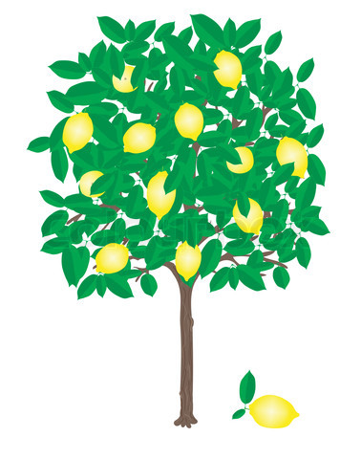](http://www.google.com/url?sa=i&source=images&cd=&cad=rja&docid=nSatnGEIuNDoYM&tbnid=tWOrFH5xeFAZVM:&ved=0CAgQjRwwAA&url=http://www.colourbox.com/vector/little-lemon-tree-with-ripe-lemons-on-it-vector-1901022&ei=7FToUeq6N4W2qQHCmoDQDg&psig=AFQjCNFexzARTzEuD29FVZwpUQcQIMV81g&ust=1374266988958512)

**Before-Listening: Discussion Questions**

* Have you ever seen a lemon tree?
* Why do you think this song is called *Lemon* *Tree*?
* What do you usually do when you’re depressed or lonely?

**Before-Listening: Vocabulary and Expressions**

1. boring: 5. isolation:
2. wasting time: 6. toy:
3. wonder: 7. heavy cloud inside my head (metaphor):
4. turning: 8. desert of joy (metaphor):

**While-Listening:**

1. The students complete the cloze activity while listening to the song: <http://www.youtube.com/watch?v=bCDIt50hRDs>
2. Then the students check their answers by watching this video: <http://www.youtube.com/watch?v=hhaeXCUfKJA>

**After-Listening: Song Meaning and Grammar Explanation**

1. Discuss song meaning, including metaphors.
2. Discuss contrast between present and present progressive and when each is used.

**After-Listening: Independent / Free Activity: Answer the following questions:**

1. What activities do you think are boring?
2. How is the weather today? Is it a rainy day?
3. What do you do when you’re hanging around with your friends or waiting for your friends?
4. What things do you wonder about?
5. A. Do you drive? B. Are you driving right now? C. Do you drive too fast sometimes?
6. A. Do you ever feel lonely? B. What do you do when you feel lonely?
7. What can you see out your window?
8. A. Do you take a shower every day? B. Are you taking a shower right now?
9. What do you do when you feel tired?
10. When do you feel joy?

**Possible alternate grammar focus:** rhyming words, compound sentences, contractions, & metaphors

***Lemon* *Tree* by Fool’s Garden**

**Cloze Passage**

**First** **Listening**: Listen to this song on YouTube and fill in the missing present progressive verbs:

<http://www.youtube.com/watch?v=bCDIt50hRDs>

**VERSE 1**

I'm here in a boring room.

It's just another rainy Sunday afternoon.

I'm my time; I got nothing to do.

I'm around; I'm for you.

But nothing ever happens, and I wonder.

I'm around in my car.

I'm driving too fast; I'm driving too far.

I'd like to change my point of view; I feel so lonely.

I'm for you.

But nothing ever happens, and I wonder.

**CHORUS**

I wonder how; I wonder why.

Yesterday you told me 'bout the blue, blue sky.

And all that I can see is just a yellow lemon tree.

I'm my head up and down.

I'm around.

And all that I can see is just another lemon tree.

Sing, dah

**VERSE 2**

I'm here; I miss the power.

I'd like to go out, taking a shower.

But there's a heavy cloud inside my head.

I feel so tired, put myself into bed.

Where nothing ever happens, and I wonder.

Isolation is not good for me.

Isolation, I don't want to sit on a lemon tree.

I'm around in a desert of joy.

Baby, anyhow I'll get another toy.

And everything will happen, and you'll wonder.

**Repeat Chorus**

And I wonder, wonder.

**Second Listening**: After you listen to the song and write the missing present progressive verbs, check your answers here:

<http://www.youtube.com/watch?v=hhaeXCUfKJA>

**What do you think this song means?**

Lyrics from: <http://www.metrolyrics.com/lemon-tree-lyrics-fools-garden.html>

**Lemon Tree by Fool’s Garden**

**Cloze Passage Answer Key**

<http://www.youtube.com/watch?v=phEnpdDusss>

**VERSE 1**

I'm **sitting** here in a boring room.

It's just another rainy Sunday afternoon.

I'm **wasting** my time; I got nothing to do.

I'm **hanging** around; I'm **waiting** for you.

But nothing ever happens, and I wonder.

I'm **driving** around in my car.

I'm **driving** too fast; I'm **driving** too far.

I'd like to change my point of view; I feel so lonely.

I'm **waiting** for you.

But nothing ever happens, and I wonder.

**CHORUS**

I wonder how; I wonder why

Yesterday you told me 'bout the blue, blue sky.

And all that I can see is just a yellow lemon tree.

I'm **turning** my head up and down. I'm **turning**, **turning, turning, turning, turning** around.

And all that I can see is just another lemon tree.   
Sing, dah

**VERSE** **2**

I'm **sitting** here; I miss the power.

I'd like to go out, taking a shower.

But there's a heavy cloud inside my head.

I feel so tired, put myself into bed

Where nothing ever happens, and I wonder.

Isolation is not the good for me. Isolation.

I don't want to sit on a lemon tree.

I'm **steppin'** around in a desert of joy.

Baby, anyhow I'll get another toy.

And everything will happen, and you'll wonder.

**Repeat Chorus**

And I wonder, wonder.

**Song Meaning:**

The song is based on the singer's life. His girlfriend died in a car accident where she crashed into a lemon tree. The lemon tree reminds him of her death, and he is sad and lonely waiting for her.  
 <http://songmeanings.com/songs/view/139247/#yHOAMuFT5ec5VttF.99>