Lemon Tree by Fool’s Garden
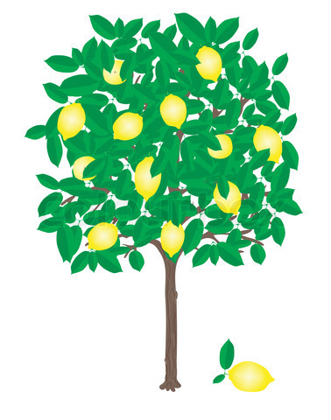
Before-Listening: Discussion Questions
- Have you ever seen a lemon tree?
- Why do you think this song is called Lemon Tree?
- What do you usually do when you’re depressed or lonely?
Before-Listening: Vocabulary and Expressions

- boring: 5. isolation:
- wasting time: 6. toy:
- wonder: 7. heavy cloud inside my head (metaphor):
- turning: 8. desert of joy (metaphor):
While-Listening:
- The students complete the cloze activity while listening to the song: http://www.youtube.com/watch?v=bCDIt50hRDs
- Then the students check their answers by watching this video: http://www.youtube.com/watch?v=hhaeXCUfKJA
After-Listening: Song Meaning and Grammar Explanation
- Discuss song meaning, including metaphors.
- Discuss contrast between present and present progressive and when each is used.
After-Listening: Independent / Free Activity: Answer the following questions:
- What activities do you think are boring?
- How is the weather today? Is it a rainy day?
- What do you do when you’re hanging around with your friends or waiting for your friends?
- What things do you wonder about?
- A. Do you drive? B. Are you driving right now? C. Do you drive too fast sometimes?
- A. Do you ever feel lonely? B. What do you do when you feel lonely?
- What can you see out your window?
- A. Do you take a shower every day? B. Are you taking a shower right now?
- What do you do when you feel tired?
- When do you feel joy?
Possible alternate grammar focus: rhyming words, compound sentences, contractions, & metaphors

Lemon Tree by Fool’s Garden
Cloze Passage

First Listening: Listen to this song on YouTube and fill in the missing present progressive verbs:
http://www.youtube.com/watch?v=bCDIt50hRDs

VERSE 1

I'm here in a boring room.
It's just another rainy Sunday afternoon.
I'm my time; I got nothing to do.
I'm around; I'm for you.
But nothing ever happens, and I wonder.

I'm around in my car.
I'm driving too fast; I'm driving too far.
I'd like to change my point of view; I feel so lonely.
I'm for you.
But nothing ever happens, and I wonder.

CHORUS

I wonder how; I wonder why.
Yesterday you told me 'bout the blue, blue sky.
And all that I can see is just a yellow lemon tree.
I'm my head up and down.
I'm around.
And all that I can see is just another lemon tree.

Sing, dah

VERSE 2
I'm here; I miss the power.
I'd like to go out, taking a shower.
But there's a heavy cloud inside my head.
I feel so tired, put myself into bed.
Where nothing ever happens, and I wonder.
Isolation is not good for me.
Isolation, I don't want to sit on a lemon tree.
I'm around in a desert of joy.

Baby, anyhow I'll get another toy.
And everything will happen, and you'll wonder.
Repeat Chorus
And I wonder, wonder.

Second Listening: After you listen to the song and write the missing present progressive verbs, check your answers here:

http://www.youtube.com/watch?v=hhaeXCUfKJA

What do you think this song means?

Lyrics from: http://www.metrolyrics.com/lemon-tree-lyrics-fools-garden.html
Lemon Tree by Fool’s Garden
Cloze Passage Answer Key
http://www.youtube.com/watch?v=phEnpdDusss

VERSE 1

I'm sitting here in a boring room.
It's just another rainy Sunday afternoon.
I'm wasting my time; I got nothing to do.
I'm hanging around; I'm waiting for you.
But nothing ever happens, and I wonder.
I'm driving around in my car.
I'm driving too fast; I'm driving too far.
I'd like to change my point of view; I feel so lonely.
I'm waiting for you.
But nothing ever happens, and I wonder.
CHORUS
I wonder how; I wonder why
Yesterday you told me 'bout the blue, blue sky.
And all that I can see is just a yellow lemon tree.
I'm turning my head up and down. I'm turning, turning, turning, turning, turning around.
And all that I can see is just another lemon tree.
Sing, dah

VERSE 2
I'm sitting here; I miss the power.
I'd like to go out, taking a shower.
But there's a heavy cloud inside my head.
I feel so tired, put myself into bed
Where nothing ever happens, and I wonder.
Isolation is not the good for me. Isolation.
I don't want to sit on a lemon tree.
I'm steppin' around in a desert of joy.
Baby, anyhow I'll get another toy.
And everything will happen, and you'll wonder.
Repeat Chorus

And I wonder, wonder.
Song Meaning:

The song is based on the singer's life. His girlfriend died in a car accident where she crashed into a lemon tree. The lemon tree reminds him of her death, and he is sad and lonely waiting for her.
http://songmeanings.com/songs/view/139247/#yHOAMuFT5ec5VttF.99

